You will need:

* A Data Factory with valid pipelines deployed
* Permission to create new resources in Azure

There’s a lot of logging & auditing out of the box with Azure Data Factory – but it’s never good to have silos of data, whether it’s your business data or your logging telemetry!

We’re going to take your existing data factory and push it’s logging to Log Analytics, a central logging repository that can be used by a whole range of Azure components!

## Lab 05.A - Create a Log Analytics Account

Before we can associate a data factory with a log analytics workspace, we need to create it!

1. In the Azure portal, create a new resource and search for “Log Analytics Workspace”
2. Give it an appropriate name and make sure to pick a region that is co-located with the azure resources you want to log from (in this case your data factory instance)

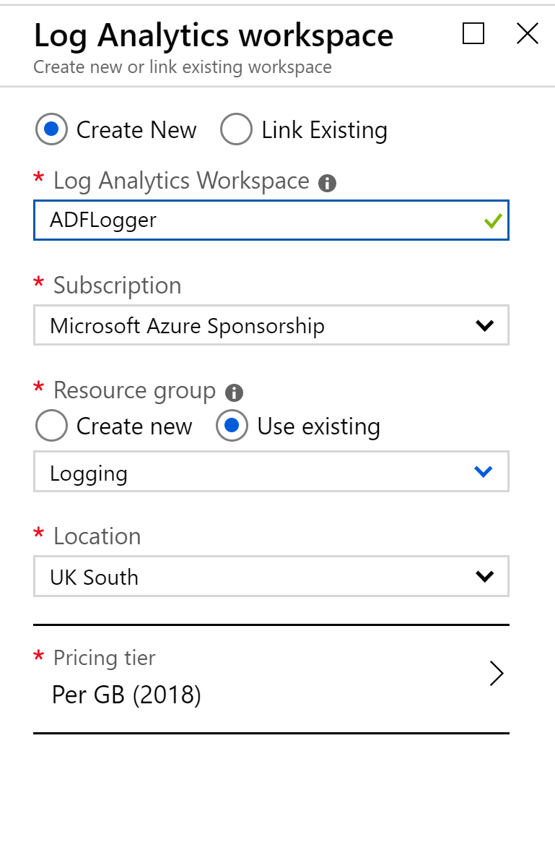

## Lab 05.B – Associate Data Factory with Log Analytics

1. Navigate to your Data Factory instance within the portal (not within the author & monitor workspace!) and click “Diagnostic Settings” on the control blade:

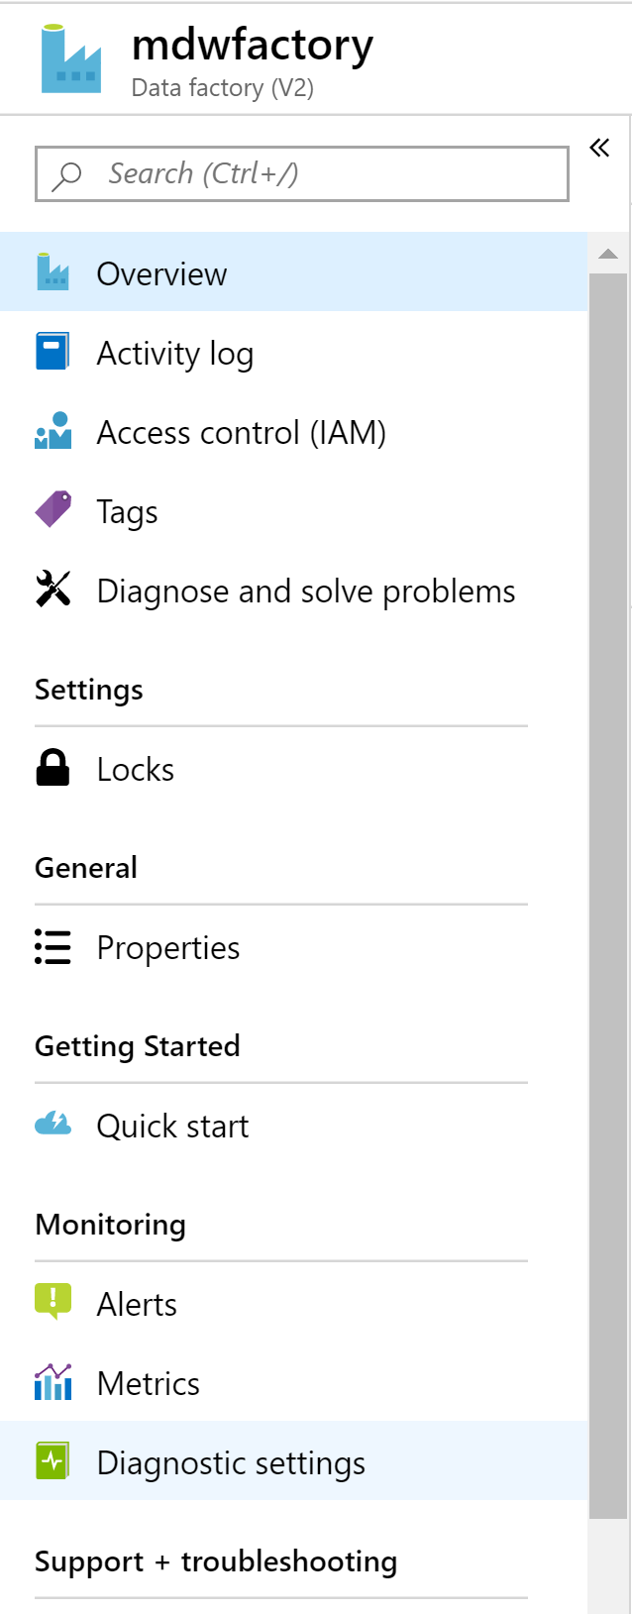

1. Click the button to add a new Diagnostic Setting

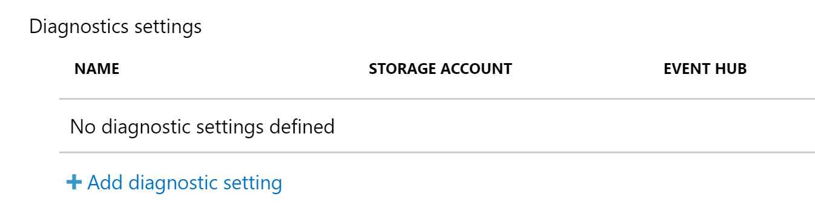

1. Set the diagnostic settings to point at your new Log Analytics service:

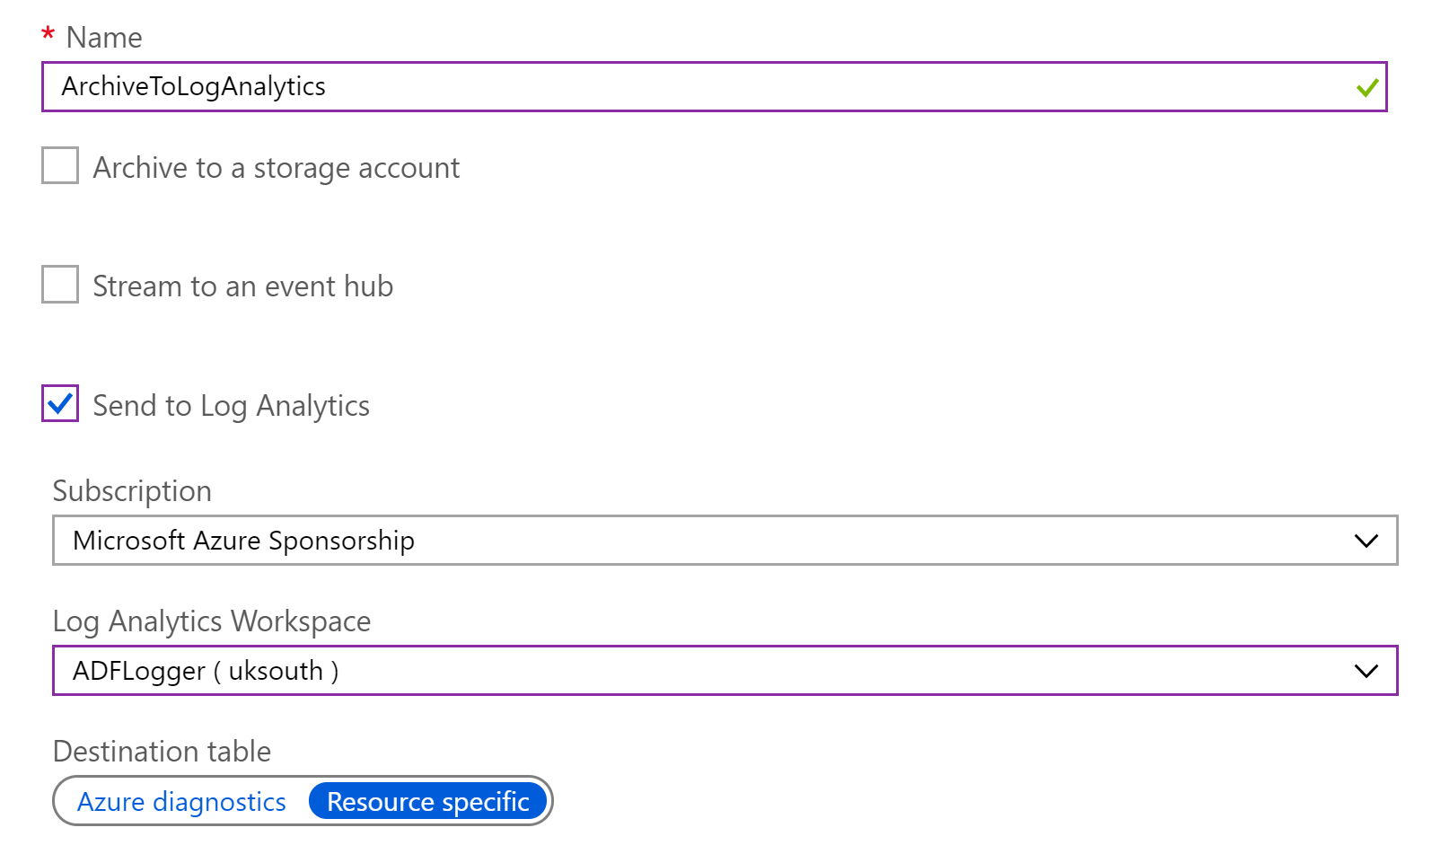

In this case, we want to capture as much detail as possible, so let’s log all metrics from all events:

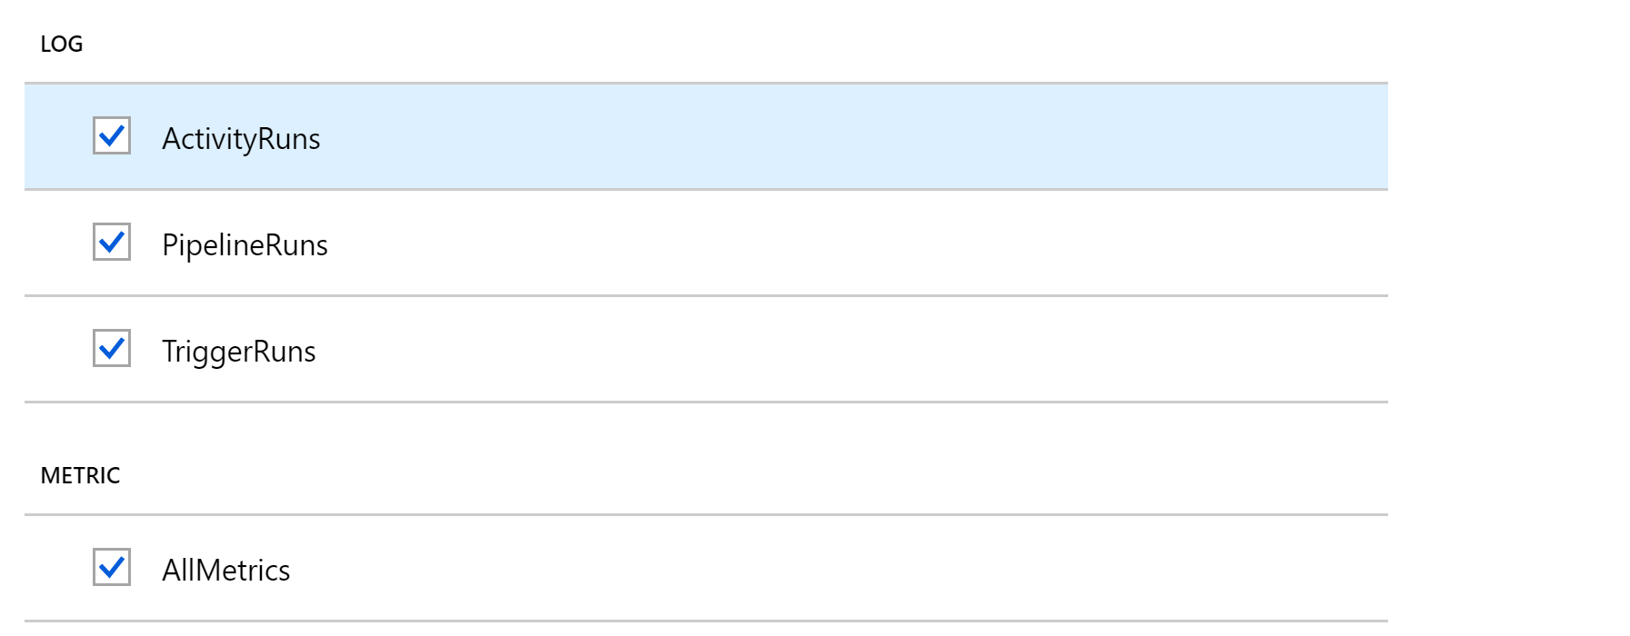

And that’s it! That’s now a fully linked Log Analytics services that’s sucking up your data factory events… but how does this help us over and above the in-built Data Factory logging?

## Lab 05.C – Using your Log Analytics Data

The main reason we use Log Analytics is to tie into any other logging that we happen to be doing, but there are some nice additional features we can hook into as well, once of which is a solution pack for ADF monitoring.

1. Install the Azure Data Factory Analytics solution pack from the Azure Marketplace

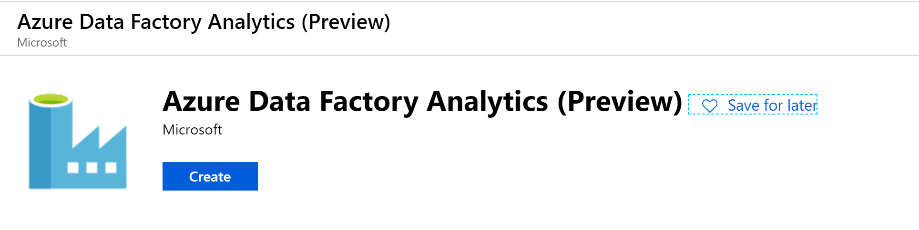

This will ask you to select a Log Analytics workspace it should be created on top of:

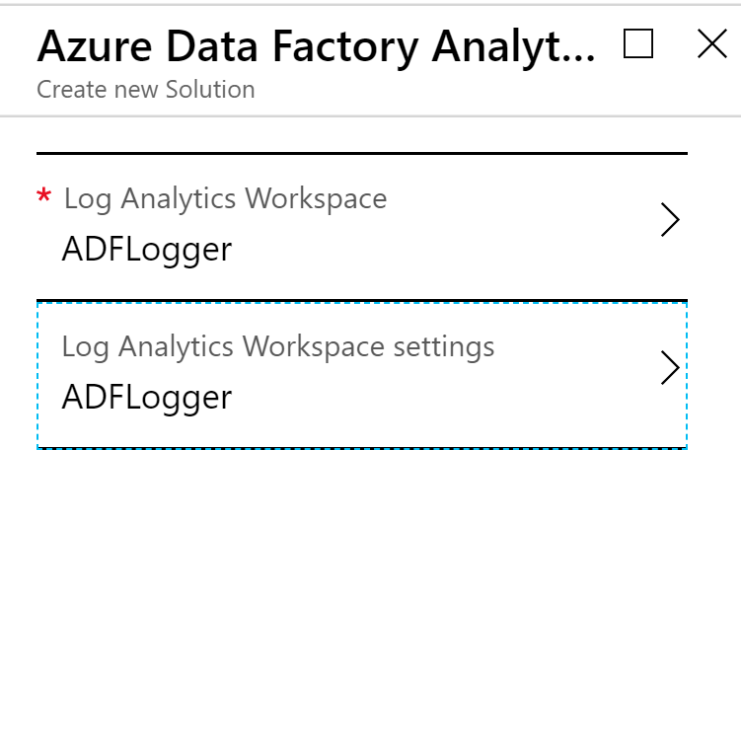

This will give you a logging workspace, including a “Summary” tab where you can drill down into some detailed dashboards:

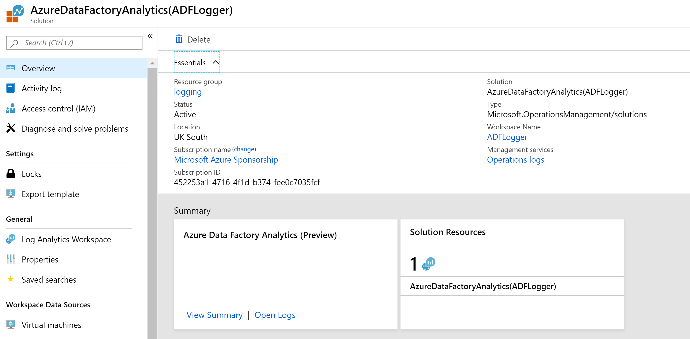

1. Click on View Summary to see the dashboards